
Year 9 Mathematics – Modified
End of Term 3 Test
Volume, Scientific Notation, Trigonometry and Statistics
Resource Section (Calculators and 1 x A4 (both sides) notes allowed)

Time: 55 mins Name: _______________________________ / 45 marks

Full working out must be shown to get full marks. Attempt all the questions.

Multi-choice Section 5 marks

- The number of goals scored by each team in a round of netball is an example of:

  - Categorical data
  - Discrete Numerical data
  - Skewed data
  - Continuous Numerical data

- The MEAN for the set of data [1, 5, 3, 5, 4, 5, 7, 9] is:

- 5
- 4.875
- 5.571
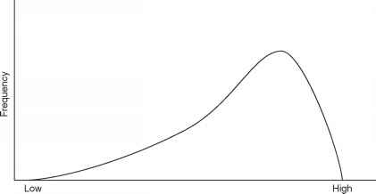
- 8

- Describe the shape of the following graph:

- Positively Skewed
- Negatively Skewed
- Symmetrical
- Bimodal

- How do we write 6 082 345 in Scientific notation?

- 6.08 x 10⁶
- 6.082345 x 10⁶
- 6.082346 x 10⁶
- 608234.6 x 10⁵

- What would be the volume of a cube, 10 cm x 10 cm x 10 cm?

- 100 cm³
- 1000 cm³
- 100 cm²
- 1000 cm²

Volume

- Fill in the following table for Units of Volume 5 marks

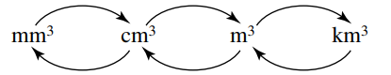

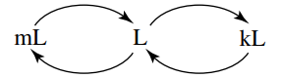

- Convert the following: 4 marks

  - 2,400,000 cm³ to ____________________ m³ c. 8.3 cm³ to ______________________ mm³

  - 2.8 mL to ___________________________ L d. 0.61 L to _________________________ mL

- Determine the volume of the following prisms and solid: 6 marks

- 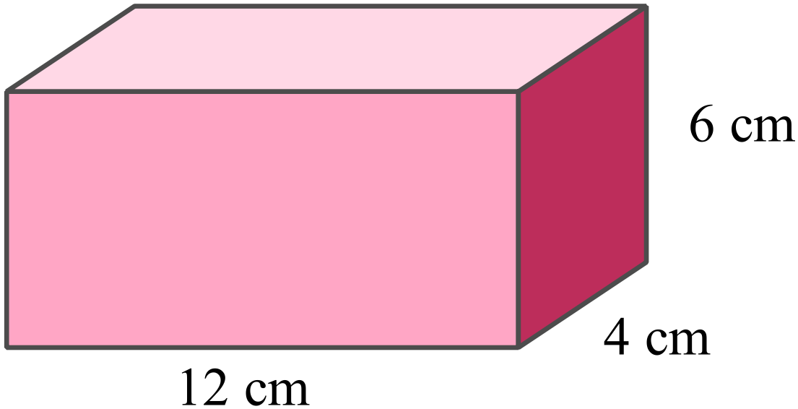 | - 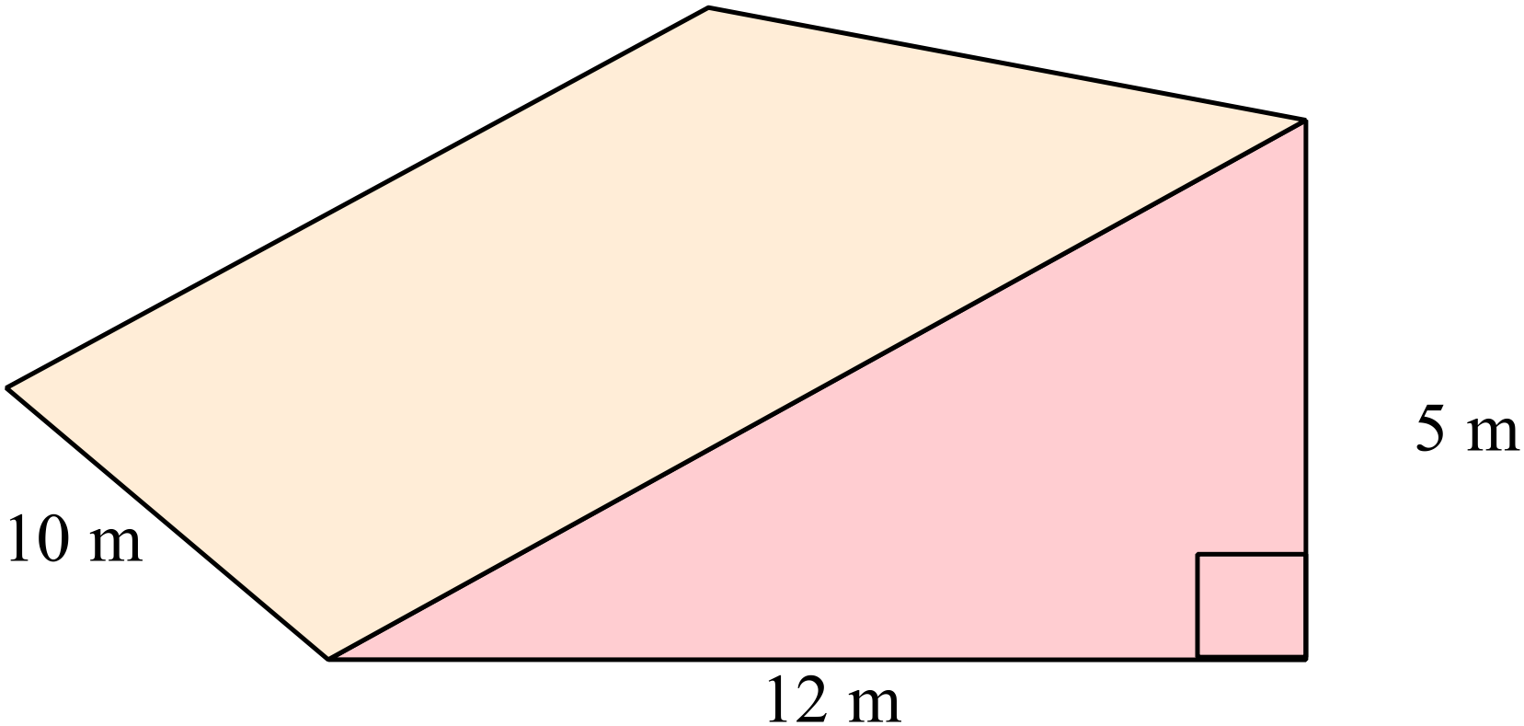  - Find the area of the triangle  - Find the volume of the prism

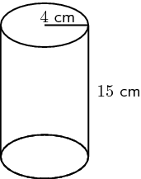
  - Find the area of the circle

  - Find the volume of the cylinder

Scientific Notation

- Complete the following table: 4 marks

Scientific Notation | Numeral
6 x 10¹
 | 600
 | 6000
6 x 10⁴

- Write the following as numerals: 2 marks

- 3 x 10⁴ = ______________________ b. 7.58 x 10⁻⁵ = ____________________

- Write the following in scientific notation: 2 marks

- 8, 000, 000 = ____________________ b. 0.009802 = _____________________

- Solve the following. Write your answer in scientific notation. 2 marks

a. (2.1 x 10²) x (3 x 10³)

Statistics

- Frida did a survey on her class and the class next door and recorded the percentage each person received on their latest math test. 4 marks

  - Is this an example of primary or secondary data? _____________________________

  - She presented the data in the graph below. What specifically is this type of graph called?

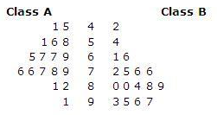

  - Which class do you think did better in the test and explain your answer.

Trigonometry

- Label the sides (Hypotenuse, Opposite and Adjacent) of the following right-angled triangle. 3 marks

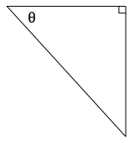

- Label the angle (Ѳ) in the correct place on the following right-angled triangle. 1 marks

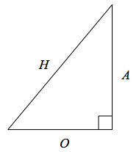

- Match the following Trigonometry Ratios with the correct triangle. 3 marks
  - Hint: Label the sides of the triangles first

$$\sin{θ=\frac{opposite}{hypotenuse}}$$ | 7 cm  Ѳ  3 cm
$$\cos{θ=\frac{adjacent}{hypotenuse}}$$ | Ѳ  14 m  4 m
$$\tan{θ=\frac{opposite}{adjacent}}$$ | Ѳ  3.5 cm  5 cm

- Use the Sin Ratio to find the length of the missing side in the following right-angled triangle. 2 marks
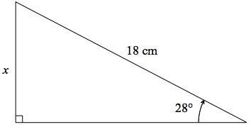

- Use the Tan Ratio to find the length of the missing side in the following right-angled triangle.
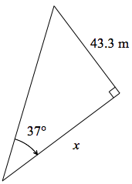
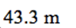
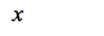
2 marks

End of Test

